 | On the beat in Oswestry Central  Newsletter | October  2026

In this edition …
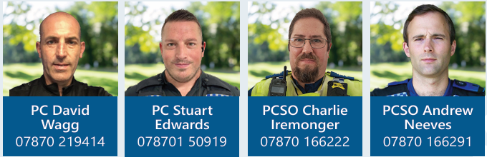

- Meet the team.

- Upcoming surgeries.

- Neighbourhood Matters

- Halloween

- Incidents of note.

Oswestry Central Safer Neighbourhood Team hold regular surgeries in and around the town and will be posting them on Neighbourhood Matters and Facebook. We welcome anyone who attends as it provides a great opportunity to meet face to face with the public, introduce ourselves and to discuss any concerns within the local communities or simply offer advice on crime prevention. We offer advice leaflets on a wide range of subjects, so please do not hesitate to ask.

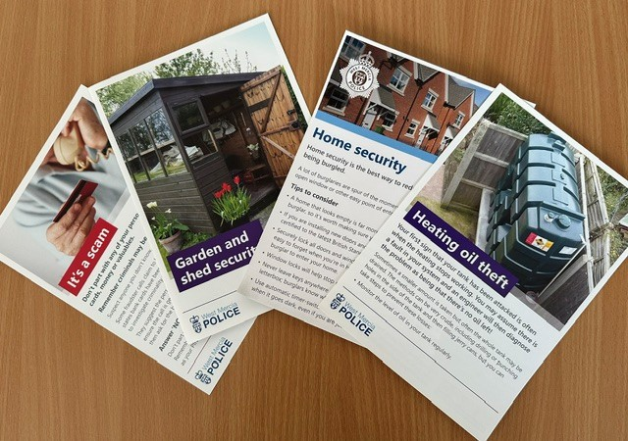

Upcoming Oswestry Central Safer Neighbourhood Team Surgeries:

14/10/2026 at Oswestry Indoor Market from 1200hrs.

15/10/2026 at Morrisons Store, Shrewsbury Road from 1700hrs.

17/10/2026 at Oswestry Library from 1200hrs.

21/10/2026 at Oswestry Library from 1600hrs.

Sign up to Neighbourhood Matters …
your community messaging service

The service allows the public to keep in touch with their local policing teams. You can choose exactly what type of alert you wish to receive and how you receive them, whether that be by email, text or telephone.

Sign up now at: www.neighbourhoodmatters.co.uk



Halloween

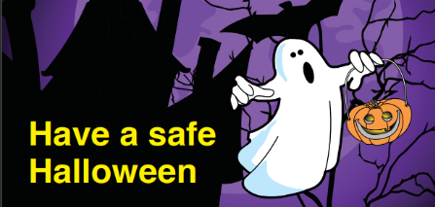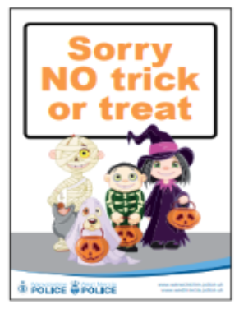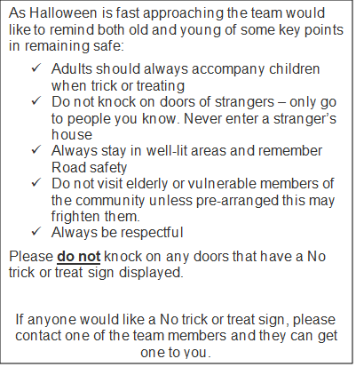

* We also have some Halloween colouring posters to keep your children entertained. Please let us know if you would like one.

Recruitment

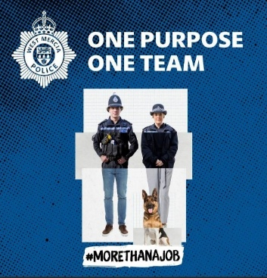

Being a police officer will give you some of the best and proudest days of your life, from protecting the vulnerable to saving lives. Every day brings new challenges, new opportunities, and the chance to make a real difference.
For more information including roles available; eligibility; entry routes and
the recruitment process please visit our website at www.westmerciapolice.co.uk

Incidents of note

Throughout September, the Oswestry Central Team have dealt with a wide range of incidents including theft from shops, anti-social behaviour concerning persons on e-scooters and e-motorbikes (see additional information below). Vehicles being driven without tax, insurance and MOT continue to be one of our priorities. The vehicle shown below was seized due to having no tax, insurance or MOT. If you have any information about vehicles being driven without the legal documents, you can report this directly to us via 101, on-line or in person at the Police station or at one of our surgeries.

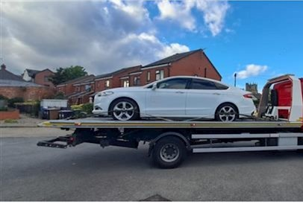

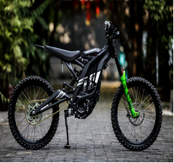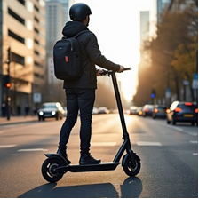

e-motorbikes e-scooters

Police have recently received complaints from residents within Oswestry in relation to e-motorbikes and e-scooters (also known as ‘powered transporters’). There is a great deal of confusion around the laws governing both e-motorbikes and e-scooters. These type of ‘powered transporters’ are classed as motor vehicles under the Road Traffic Act 1988. This means the laws that apply to motor vehicles, also apply to e-motorbikes and e-scooters, including the need to have a licence, tax, and insurance. Any person using this mode of transport in a public place without the required legal documents will be subject to seizure of their motorbike/scooter. Police are therefore keen to raise awareness of the legal requirements around these popular items, particularly with the festive season not far away.

