 | On the beat in Ellesmere Town and Rural  Newsletter | July/August  2026

In this edition …
Meet the team

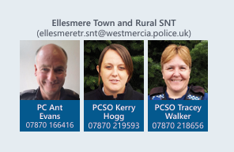
Team email: ellesmeretr.snt@westmercia.police.uk

Upcoming engagements:

- 11th September 13:00-14:00 Ellesmere Market, Scotland Street
- 14th September 15:00 – 15:30
Near to Welshampton village hall
- 16th September 17:00-17:30
Cockshutt Millenium Hall
- 22nd September 09:00-09:30
Baschurch Village Hall
- 22nd September 10:30-11:00
Criftins Village Hall car park
- 29th September 14:00-15:00
Ellesmere Our space

• Meet the team
• Upcoming engagements
• Neighbourhood matters
• Operation Spotlight
• Incidents of note within the area
• successful events and engagements
• Road safety
• Recruitment

Sign up to Neighbourhood Matters …
your community messaging service

The service allows the public to keep in touch with their local policing teams. You can choose exactly what type of alert you wish to receive and how you receive them, whether that be by email, text or telephone.

Sign up now at: www.neighbourhoodmatters.co.uk



Operation Spotlight

During September, we will once again be supporting Operation Spotlight, a national campaign highlighting the work of roads policing officers, local policing teams, and communities to reduce the number of people killed or seriously injured on our roads and make them safer for everyone



Incidents of note

- During July and August there were intentional open-air fires started at the Mere and the cricket club. These were attended by Shropshire Fire and Rescue service, who successfully extinguished them before substantial damage was caused.
- As with previous years, Ellesmere Carnival was a success and there were no incidents reported, however information was received regarding underage consumption of alcohol.
- A successful first summer with the Pump track, there were no significant issues, complaints were received about older children preventing younger ones engaging in the usage of the track, these youths were spoken to and the issue was resolved.
- Youths were reported to be causing antisocial behaviour within Swanmere court by knocking on doors in the early hours, this caused some distress to the residents, the youths were identified and spoken to in company with parents/guardians with apologies following shortly afterwards, reassurance was provided by the local team to those affected.
- A single attempted burglary happened on charlotte row where individuals were seen to enter the rear yard of a property, these individuals were disturbed, no access was gained to the premises, there were no further incidents reported.
- An attempted theft of motor vehicle resulting in criminal damage occurred in Dudleston Heath.

There are currently on-going investigations relating to some of these incidents, please contact the team should you have any information or to raise any concerns

The team would like to take this time to remind people to keep their property and belongings safe. Please ensure locks work correctly and are used, do not leave doors, windows and vehicles unlocked or open.
If you require any crime prevention advice, support or have queries or information, please contact your local team members who will be happy to assist the best they can.

BikeRegister
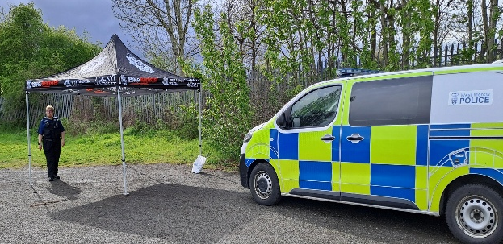
The team have conducted several successful Bike registration events this year and will be arranging more in the near future:
This offers cyclists the opportunity to have their bikes marked for free using BikeRegsiter, which helps to deter theft, supports identification of stolen bikes and increases the likelihood of reuniting recovered cycles with their owners.

Events will be advertised on Neighbourhood Matters and also on the Oswestry and Ellesmere Facebook page. Please visit www.neighbourhoodmatters.co.uk for upcoming dates and locations


Recruitment

Being a police officer will give you some of the best and proudest days of your life, from protecting the vulnerable to saving lives. Every day brings new challenges, new opportunities, and the chance to make a real difference.
For more information including roles available; eligibility; entry routes and
the recruitment process please visit our website at www.westmerciapolice.co.uk

