 | On the beat in  Martley And Tenbury Wells  Safer Neighbourhood Team Newsletter | September  2026

Where we work
Abberley, Astley & Dunley, Bayton, Eastham, Clifton On Teme, Mamble, Tenbury Wells, Great Witley, Grimley, Hanley, Wichenford, Holt Heath, Hallow, Knighton On Teme, Lindridge, Little Witley, Lower Sapey, Martley, Pensax, Rochford, Shelsley Walsh, Shrawley, Stanford & Orleton, Stoke Bliss, Kyre, Bockleton, St Micheals, Newnham Bridge, Eardiston.
Team contact details
Team email: mt.snt@westmercia.police.uk
Police Community Support Officer: PCSO Partridge Mobile: 07870399400

Community Update
This quarter has been a challenging one for the Safer Neighbourhood Team. Following staffing changes, the team has been operating with reduced numbers whilst continuing to cover a large rural policing area. Although this has meant fewer opportunities to attend community events and engagements than we would normally like, we have remained committed to serving our communities through daily patrols, responding to concerns raised by residents and supporting partner agencies where required. We would like to thank residents and parish councils for their continued support and understanding during this period.
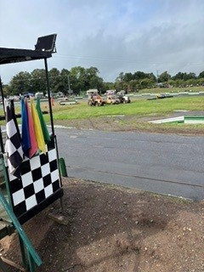
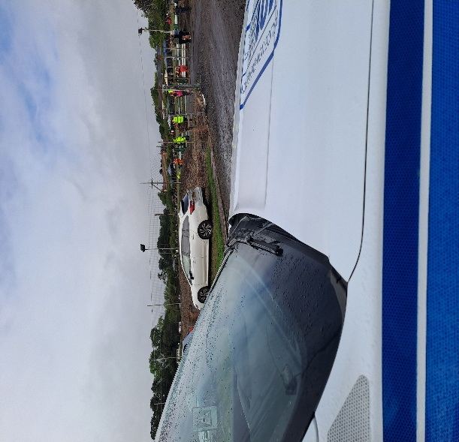
Grimley Race Track

Good News
We have now unfortunately lost PC Hand to another department within West Mercia Police so he no longer works for Tenbury SNT team, however we did manage to gain a hybrid officer PC Hawkins who joined the team this month, if you see him out on patrol make sure to have a chat with him he has many years’ experience in the police.
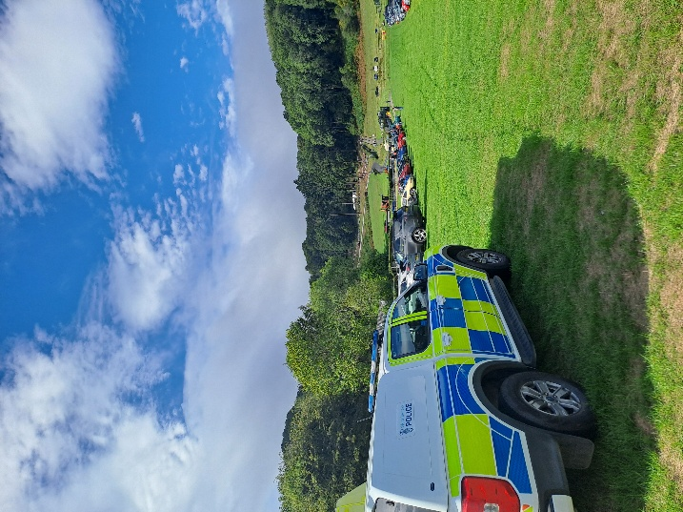
Shelsley Walsh Hill Climb

Rural Community Priorities
Throughout the quarter we have continued to monitor concerns raised by parish councils and residents. Some of the issues regularly discussed with us include;
-Excess speed in villages.
-Anti-social behaviour.
-Rural crime.
-Suspicious vehicles and persons.
-Parking concerns around schools and local amenities.
Information from residents remains one of our most valuable tools in identifying and tackling these issues, so please continue to report concerns when they arise.
The Work You Don't Always See
Not all policing activity takes place at community events or on high streets. A large amount of our time is spent;
-Following up intelligence reports.
-Conducting enquiries into reported incidents.
-Supporting vulnerable members of our communities.
-Working alongside partner agencies.
-Carrying out safeguarding work.
-Providing reassurance and advice to victims.
-Gathering information that helps prevent future crime.
Whilst much of this work takes place behind the scenes, it remains an important part of keeping our communities safe.

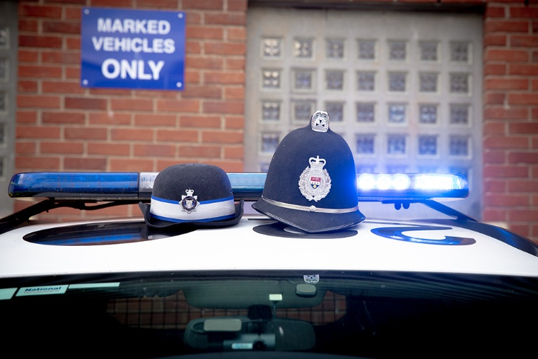

Crime Prevention Advice
As we approach the darker evenings, please take a few simple steps to help protect your property:
-Home Security
-Lock doors and windows, even when at home.
-Use external lighting where possible.
-Keep valuables out of sight.
-Vehicle Security
-Remove valuables from vehicles.
-Ensure vehicles are locked and secured.
-Report suspicious activity around parked vehicles.
-Keep gates, sheds and outbuildings secure.
-Record serial numbers of valuable equipment.
-Report suspicious vehicles or activity immediately.

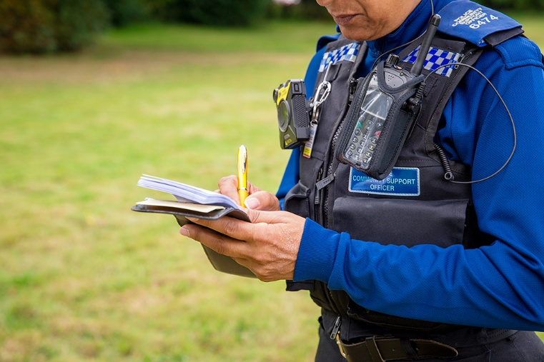
Looking Ahead
We hope to increase our opportunities for community engagement over the coming months and continue to attend parish meetings and surgeries wherever operational demands allow. The team remains committed to listening to residents' concerns and working with local communities to address issues affecting our rural areas.
Safer Neighbourhood Team
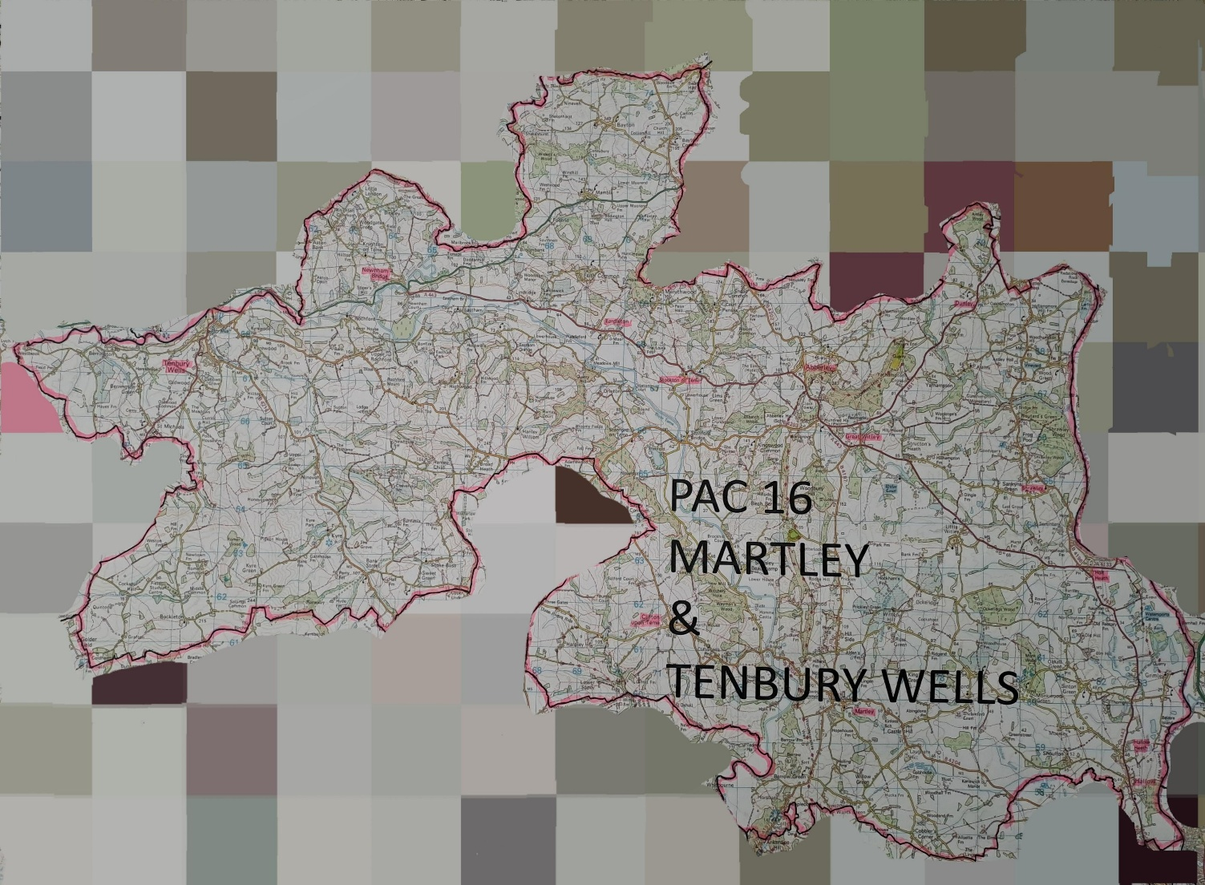
PCSO Partridge
Hybrid Officers
PC Hart & PC Hawkins
Sign up to Neighbourhood Matters … your brand new community messaging service. 
Neighbourhood Matters enables residents, businesses and community groups to keep in touch with local policing teams. You can choose exactly what type of alert you wish to receive and how you receive them; whether that be by email, text or telephone.
Sign up now at: www.neighbourhoodmatters.co.uk

Report crime through these channels;
101 or our website https://www.westmercia.police.uk/ for non emergencies.
999 for emergencies.
Total anonymity https://crimestoppers-uk.org/

