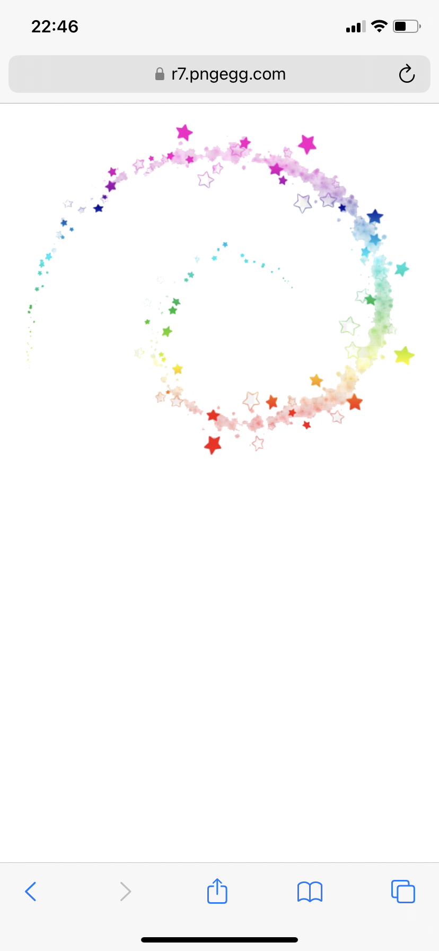
Police Academy Sports Stars
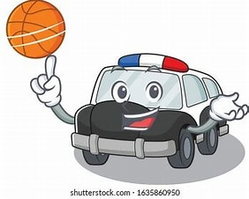

Free Event!!

Calling all 8–14-Year-olds
Join us on Tuesday 4th of August 2026 at 13:30-15:30 for some fun filled sports activities at Halo Leisure Centre, Bridge Street, Leominster, HR6 8EA
Free Drinks and snacks will be provided. All you need to do is turn up and have suitable PE clothing.
Scan the QR code below to book a place today or email Leominster.snt@westmercia.police.uk to request consent form



