On the beat in
Hereford Southside & Rural
Safer Neighbourhood Team Newsletter May 2026

Where we work
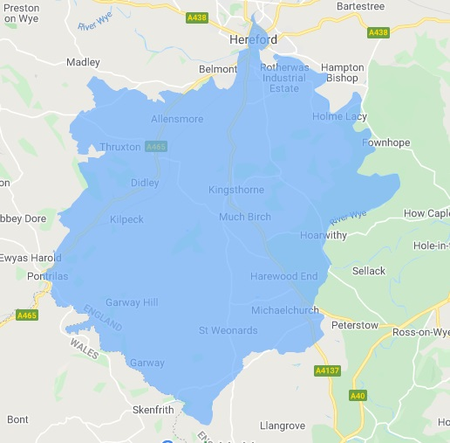

Team contact details
Team email: herefordsouthside.snt@westmercia.police.uk
Safer Neighbourhood Officer: PC 21946 Jack Davies Mobile: 07817 158224
Safer Neighbourhood Officer: PC 21198 Brian Gosson Mobile: 07973 846336
Safer Neighbourhood Officer: PC 21260 Martin Gillett Mobile: 07970 544262
Safer Neighbourhood Officer: PC 22088 Dan Ovel Mobile: 07929 721340
Police Community Support Officer: PCSO 6324 Carol Marsh Mobile: 07890 524667
Police Community Support Officer: PCSO 40259 Hayley Warne Mobile: 07773 052560
Police Community Support Officer: PCSO 40272 Lewis Thomas Mobile: 07773 051508
We are happy to receive calls from Members of The Public, however, please do not use these to report crimes and/or incidents. For more information on reporting a crime/incident please go to www.westmercia.police.uk and select ‘Report’ or call 999 (Emergency) / 101 (Non-Emergency)

In this edition

- Garden Security
- Come and Meet
- Op Hartwell
- Bike Marking
- Clamping Down
- Smelly Smoking
- NHM

Garden Security
We have received several reports of young people entering peoples gardens via hopping over the fence. These incidents are occurring late at night – no specific area of the City.
There are many ways that this can be addressed by the resident.
Here are the best ways to secure your garden, based on security advice:
Physical Security and Boundaries
- Secure Fences & Trellis: Ensure rear fences are at least 1.8m high to make climbing difficult. Adding trellis to the top of fences can deter climbers, as it is fragile and creates noise.
- Defensive Planting: Plant prickly or thorny shrubs (e.g., Pyracantha, Holly, Berberis, or Rose bushes) at the base of fences, walls, and under windows to act as a natural, painful barrier.
- Secure Gates: Always keep side gates locked with two high-quality locks, ideally top and bottom, and ensure they are properly anchored.
- Use Gravel: Gravel driveways and paths act as an alarm system, as it is nearly impossible to walk on them quietly.
- Anti-Climb Measures: Use plastic fence spikes or trellis to deter intruders from scaling fences. You can also buy Anti-vandal paint, or anti-climb paint, is a thick, permanently tacky coating that remains non-drying to make surfaces impossible to climb and to mark intruders with staining paint. It is ideal for pipes, ledges, and fences, typically applied at heights above to avoid accidental contact.
- CCTV & Doorbell Cameras: these are great for evidential purposes as well as adding another layer of security.


🌟 Come and Meet Your Local Southwye Safer Neighbourhood Team! 🌟
Over the next few weeks, we’ll be out and about in the community. Pop by, say hello, and chat with us about any concerns you may have — or just come along for a friendly conversation. We may even have a few freebies to give away! 😊
📅 Find us at:
• ☕Newton farm Community Hub – The Oval – Coffee Morning
⏰ 09:30–11:30 – May 18th
• 🛒Dementia Action Week –St. Martin’s Church
⏰ 12:00–13:00 – May 20th
• 🛒Meadowfest – Bishop Meadow Community Sports Park – Police Van
⏰ 11:00–14:00 – May 24th
• ☕ Eastholme Community Centre – Coffee Morning
⏰ 10:30–12:00 – June 5th

• ☕Hinton Community Centre – Community Coffee with Boxers Cakes
⏰ 13:30–15:30 – June 5th
• ⛪ Our Lady’s Queen of Martyrs Catholic Church (Belmont Road) – Coffee Morning
⏰ 10:30–12:00 – June 9th
• ☕Newton farm Community Hub – The Oval – Coffee Morning
⏰ 09:30–11:30 – June 15th
COMING SOON - Coffee with a cop in the evening .
We’d love to see you there! 👋💙

Op Hartwell
Some of our SNT officers were involved with a recent operation targeting rural crime themes. The operation coincided with the eve of the Stow Horse Fair in Gloucestershire, a historic event where there is an upsurge in movement of horses, livestock, large agricultural machinery and traders across the country.
Whilst the fair generally experiences low levels of criminality it can attract individuals who are involved in the trade of stolen goods or illegally held wildlife, some of whom are linked to Organised Rural Crime groups.
A very productive operation that had many positive results:
A4137 Marstow:
45 cars speed checked (no speeding offences identified).
2 x words of advice given for movement of cattle in trailer which didn’t have a number plate.
1 x TOR for use of mobile phone.
A49 – Peterstow and Bridstow:
2 x words of advice given for brake lights not working
1 x words of advice for brake lights not working on trailer
No speeding offences identified.
Walford Road, Ross:
50 x vehicles checked – no speeding identified at the time of checks.
1 x resident spoke to Police – thanking them for conducting speed checks. Discussed SID signs and general information related to the Community Speed Watch group.
1 x stop check on vehicle parking inconsiderately on Walford Road junction – words of advice given.
ANPR – 1 x vehicle checked – it was all in order following checks.
Goodrich:
1 x TOR for no number plate
1 x TOR for not wearing a seatbelt.
Ross High Street & Engagement Van:
Words of advice given to a vehicle looking to drive down a one-way system.
A few members of the public attended and engaged.
6 x bikes marked in Llangrove.
Further opportunity discovered for Bike Marking – “Repair Café” where the team can bike mark.
A40 layby:
30: Vehicles processed on site. 1: Arrest... by Sgt Alice Bennett
30: Vehicles processed on site.
1: Arrest- off site by Traffic Officers for Drug/Drive Offences.
2: Vehicles seized- No Insurance.
13: Drivers reported/processed for traffic offences- including No Insurance; Overladen vehicle/trailer; Expired MOT; Vehicle Defects
1: HMRC red diesel offence- HMRC fine - £530 issued.
1: Herefordshire Council Enforcement Team: £300 fine for waste carrier offences.
1: Herefordshire Council Enforcement Team: seizure of illegal foodstuff, (meat and dairy) completed and issue of FPN.
1: Herefordshire Council Enforcement Team: formal warning issued to livestock, (cattle) carrier- failure to properly record movement of animals’ offences.
5: Caravan Central Registration & Identification Scheme, (CRiS) caravan ownership checks.

Bike Marking
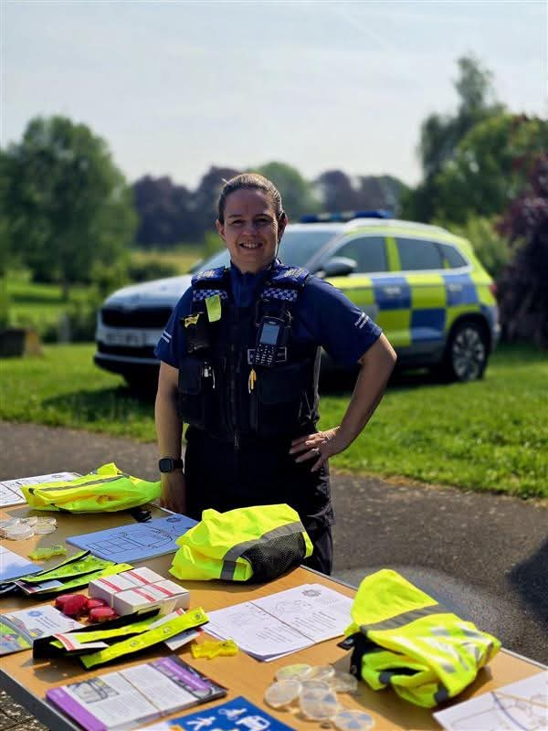
South Wye Police would like to say a huge thank you for having us at the Halo Big Open Day last Saturday!
We carried out bike marking throughout the day and had some fantastic community engagement 🚴‍♂️
It was great to speak with so many members of the public, and we were able to property mark several bikes —helping to keep them safe and easier to identify if lost or stolen.
Thank you to everyone who came along to chat with us and get involved – your support is always appreciated!
👀 Watch this space for details of our next event coming soon – we hope to see you there!


Community Alert: Clamping Down on Dangerous Riding in Hereford
We all love the thrill of the open road, but reckless riding crosses a dangerous line. Performing wheelies on public roads might look like harmless fun, but it carries immediate, life-altering consequences for you and everyone around you.
We all love the thrill of the open road, but reckless riding crosses a dangerous line. Performing wheelies on public roads might look like harmless fun, but it carries immediate, life-altering consequences for you and everyone around you.
The Local Issue: Anti-Social Riding Hotspots
A high volume of community complaints has been received regarding motorcyclists riding in an unruly manner and pulling wheelies in heavily populated areas. These riders are operating dangerously around both pedestrians and moving vehicles in several specific locations across Hereford:
Rotherwas Industrial Estate: Posing a severe risk to workers and commercial traffic.
Bishops Meadows: Endangering families, dog walkers, and cyclists in a primary recreational green space.
Saxon Gate: Risking collisions in built-up, tight-knit residential zones.
Newton Farm: Threatening public safety on busy neighbourhood streets and pavements.
The Immediate Dangers of Street Stunting
- Total Loss of Control: Lifting the front wheel eliminates all steering capabilities and a significant chunk of your braking power. A fraction of a second is all it takes to trigger a violent handlebar wobble or a backward loop.
- Severe Blind Spots: When a bike is vertical, the rider's forward vision is completely blocked by the front fairing and wheel. They literally cannot see pedestrians crossing the road ahead.
- Zero Margin for Error: In highly populated areas, a single patch of oil, loose gravel, or an unexpected car brake will result in a catastrophic high-speed crash.
Accountability and Action
West Mercia Police monitor anti-social vehicle use very closely. Under UK law, performing wheelies on public highways is classified as dangerous driving. Officers have the strict legal authority to immediately seize, impound, and permanently crush vehicles operated in this manner.
Please keep your wits about you when out and about; this stupid, reckless behaviour can cause life-altering injuries in a heartbeat.
Report Nuisance Vehicles: If you witness dangerous riding or have dashcam footage of riders in these areas, please report it directly via the West Mercia Police Online Reporting Tool or call 101 to help keep Hereford's roads safe.

Suspicious Vehicles
If you spot vehicles idling or loitering near properties these can be flagged as suspicious when the behaviour deviates from normal community patterns and lacks a clear, legitimate purpose. Questions you ask yourself are: Do I know that vehicle? Are they a delivery van? That doesn’t sit right? Dial 101 or report the vehicle/driver description right away.
Distinguishing Crime Scoping from Normal Behaviour
Before contacting the police, cross-reference the behaviour against standard neighbourhood occurrences:
Behaviour | Legitimate Explanation | Suspicious Red Flag
Delivery Drivers | Brief stops, visible packages, high-visibility clothing, clear delivery app activity. | Extended sitting, no deliveries made, scanning properties instead of searching for addresses.
Lost Drivers | Slow driving, stopping to look at phone maps or house numbers, executing quick U-turns to leave. | Circling identical streets repeatedly, turning off headlights while moving, or idling for hours.
Gig Workers (Uber/Le飲食) | Parking with hazard lights on, checking phones continuously, clear passenger interaction. | Parking far from active homes, keeping lights off, occupants stepping out to investigate side alleys.

Smelly Smoking
More reports are being received daily regarding the smoking of cannabis, whether it is smoked inside a property, in the garden or anywhere public, we must remember it is still illegal and a crime to do so. If you live in rented accommodation, it is a breach of your tenancy and can lead to eviction.
Smoking weed typically induces short-term euphoria, altered sensory perceptions, and increased appetite, often accompanied by impaired memory, judgment, and coordination. Potential risks include anxiety, paranoia, panic attacks, respiratory issues (like chronic bronchitis), and potential addiction. Long-term effects can include cognitive impairment, particularly if used during adolescence. DO NOT drive/ride any wheeled vehicle as it will result in:
Legal Penalties
- Driving Ban: An automatic minimum 12-month disqualification.
- Criminal Record: A conviction will stay on your license for 11 years.
- Fines & Prison: Fines can be up to £5,000, and there is a potential for up to 6 months in prison.
- Fatal Accidents: If you cause a death while under the influence of drugs, you face up to life imprisonment.
British Transport Police +2
What Happens When You're Caught
- Roadside Tests: Police can use a "field impairment assessment," such as asking you to walk in a straight line.
- Drug Kits: Roadside saliva kits can test for cannabis within 24–72 hours of use.
- Blood/Urine Test: If you fail the roadside test, you will be arrested and required to provide a blood or urine sample at a police station

West Mercia Police treat cannabis as a Class B drug and take active measures to target its cultivation, sale, and use, including stopping individuals smoking it in public or residential areas. While cannabis remains illegal, the force may use discretion and evidence-based interventions for personal possession, rather than immediate, automatic prosecution.

Neighbourhood Matters
Sign up to Neighbourhood Matters your brand-new community messaging service.
Neighbourhood Matters enables residents, businesses and community groups to keep in touch with local policing teams. You can choose exactly what type of alert you wish to receive and how you receive them, whether that be by email, text or telephone.

Sign up now at: www.neighbourhoodmatters.co.uk

