 | On the beat in Oswestry Rural North  Newsletter | September/October  2026

In this edition …
Meet the team

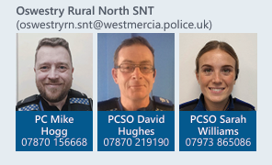
Team email: oswestryrn.snt@westmercia.police.uk

Upcoming engagements - October 2026

8th October 11:30-12:00 - St Johns Church, Weston Rhyn
8th October 15:30-16:00 - All Saints Church, Gobowen
15t October 10:00 – 10:30 – White Lion Pub Car Park, Whittington
17th October 14:00-14:30 – Stans, St Martins
27th October 13:00-13:30 – Pavillion, Gobowen
28th October 14:00-14:30 – White Lion Pub Car Park, Whittington.

• Meet the team
• Upcoming engagements
• Neighbourhood matters
• Operation Spotlight
• Incidents of note within the area
• successful events and engagements
• Road safety
• Recruitment

Sign up to Neighbourhood Matters …
your community messaging service

The service allows the public to keep in touch with their local policing teams. You can choose exactly what type of alert you wish to receive and how you receive them, whether that be by email, text or telephone.

Sign up now at: www.neighbourhoodmatters.co.uk



Recruitment
Being a police officer will give you some of the best and proudest days of your life, from protecting the vulnerable to saving lives. Every day brings new challenges, new opportunities, and the chance to make a real difference.
For more information including roles available; eligibility; entry routes and
the recruitment process please visit our website at www.westmerciapolice.co.uk

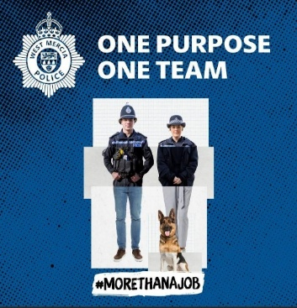

Incidents of note

- One male was detained near to the Orthopaedic hospital, in possession of Class B drugs, male was issued with a out of court disposal for the offence.
- ASB Whittington – Youths knocking on doors and making off, causing a disturbance to people in their homes. SNT have ring doorbell footage and have been able to identify the youths and have been dealt with accordingly.
- Three vehicles in Oswestry Rural north have been seized for No TAX. If any vehicles in your area have No TAX, please get in contact with the team.
- 5 speed enforcement activities have been completed across the four areas, 7 vehicles being reported for excess speed.
- Concerns have been raised to the team in relation to parking outside St Martins, School. A majority of motorist’s are parking in the bus lane, on double yellow lines and parking in front of people’s driveways. We would like to remind motorists to park their vehicles legally and considerately.
- Rural Crime, there have been several agricultural thefts in the area, they are being currently investigated with enquires on going. Please be vigilant and report any suspicious activity. The neighbourhood team and local officers will be completing high visibility patrols in these areas.

Halloween
As Halloween is fast approaching the team would like to remind both old and young of some key points in remaining safe:
- Adults should always accompany children when trick or treating
- Do not knock on doors of strangers – only go to people you know. Never enter a stranger’s house
- Always stay in well-lit areas and remember Road safety
- Do not visit elderly or vulnerable members of the community unless pre-arranged this may frighten them.
- Always be respectful
Please do not knock on any doors that have a No trick or treat sign displayed.

If anyone would like a No trick or treat sign, please contact one of the team members and they can get one to you.


