 | On the beat in Oswestry Rural North  Newsletter | August  2026

In this edition …
Meet the team

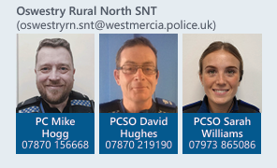
Team email: oswestryrn.snt@westmercia.police.uk

upcoming engagements:

Surgery
Stan’s 22/09 14:30 – 15:00
Weston Rhyn St John’s Church 24/09 12:00 – 12:30

• Meet the team
• Upcoming engagements
• Neighbourhood matters
• Operation Spotlight
• Incidents of note within the area
• successful events and engagements
• Recruitment

Sign up to Neighbourhood Matters …
your community messaging service

The service allows the public to keep in touch with their local policing teams. You can choose exactly what type of alert you wish to receive and how you receive them, whether that be by email, text or telephone.

Sign up now at: www.neighbourhoodmatters.co.uk



Operation Spotlight

During September, we will once again be supporting Operation Spotlight, a national campaign highlighting the work of roads policing officers, local policing teams, and communities to reduce the number of people killed or seriously injured on our roads and make them safer for everyone

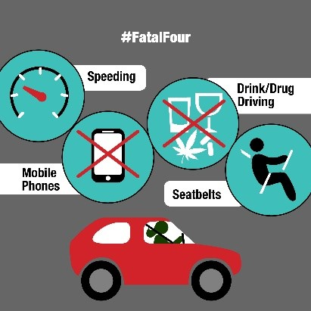

Incidents of note

Rural Crime

Two Rural thefts reported to us during September: agricultural vehicles and equipment stole from two locations; one in the Weston Rhyn area and the other in the St Martins area where two persons were arrested which is still an ongoing investigation.
The team would like to take this opportunity to remind residents and local businesses to ensure both their home and business premises and equipment are secure, simple things such as making sure windows and closed and locked when leaving buildings can make all the difference.

If you require any crime prevention advice, support or have queries or information, please contact your local team members who will be happy to assist the best they can.

Anti-social Behaviour

There have been several reports of ASB recently from Whitting and St Martins, this includes Children knocking on doors and making off. SNT have ring doorbell footage from some of these incidents and are working to identify those involved in causing a nuisance within our community.

Incidents of a house being egged in the Churchfield’s area of St Martins, 3 youths have been identified via CCTV and are currently being dealt with appropriately.

Greenfields St Martins an elderly resident’s home was splattered with wet paper towels, this is an ongoing issue, 3 youths have been identified by CCTV and were dealt with accordingly. There have been no further incidents of this nature since SNT intervention.

This behaviour will not be tolerated; it causes unnecessary stress to residents and those involved will be dealt with inline with anti-social behaviour guidance.

Oswestry Show

Oswestry show was once again a success with no reported incidents.
Thank you to in attendance that engaged with the local officers and those that had questions for SNT, firearms licensing and the rural crime officer.
We look forward to seeing you all next year.

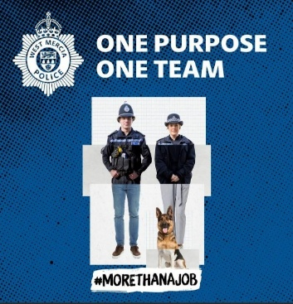
Recruitment

Being a police officer will give you some of the best and proudest days of your life, from protecting the vulnerable to saving lives. Every day brings new challenges, new opportunities, and the chance to make a real difference.
For more information including roles available; eligibility; entry routes and
the recruitment process please visit our website at www.westmerciapolice.co.uk

