 | On the beat in Oswestry Central  Newsletter | October  2026

In this edition …
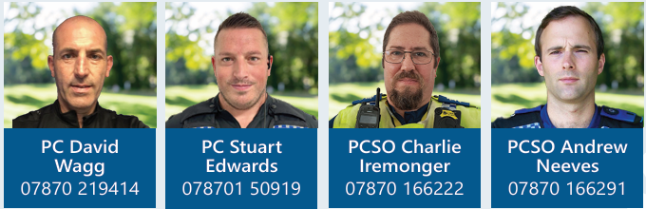

- Meet the team.

- Upcoming surgeries.

- Neighbourhood Matters

- Incidents of note.

Oswestry Central Safer Neighbourhood Team hold regular surgeries in and around the town and will be posting them on Neighbourhood Matters and Facebook. We welcome anyone who attends as it provides a great opportunity to meet face to face with the public, introduce ourselves and to discuss any concerns within the local communities or simply offer advice on crime prevention. We offer advice leaflets on a wide range of subjects, so please do not hesitate to ask.

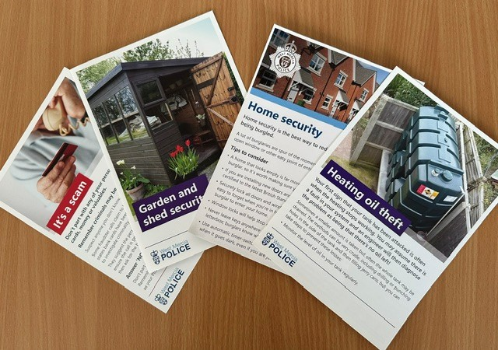

Upcoming Oswestry Central Safer Neighbourhood Team Surgeries:

03/11/2026 09:30 @ Oswestry Library
04/11/2026 12:00 @ Oswestry Library
09/11/2026 17:00 @ Morrisons, Oswestry
11/11/2026 09:30 @ Oswestry Library
16/11/2026 12:30 @ Oswestry Library
18/11/2026 12:00 @ Oswestry Indoor Market
30/11/2026 12:30 @ Oswestry Library

Sign up to Neighbourhood Matters …
your community messaging service

The service allows the public to keep in touch with their local policing teams. You can choose exactly what type of alert you wish to receive and how you receive them, whether that be by email, text or telephone.

Sign up now at: www.neighbourhoodmatters.co.uk



Recruitment

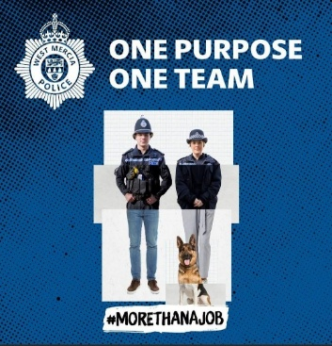

Being a police officer will give you some of the best and proudest days of your life, from protecting the vulnerable to saving lives. Every day brings new challenges, new opportunities, and the chance to make a real difference.
For more information including roles available; eligibility; entry routes and
the recruitment process please visit our website at www.westmerciapolice.co.uk

Speed Checks
Speed checks has been carried out on 04/10/2026 at the following locations:
Upper Brook Street, Oswestry
Morda Road, Oswestry. Two vehicle was recorded going over the 30mph speed limit.
Whittington road, Oswestry. Three vehicles were recorded going over the 30mph speed limit.

School patrols continue to help educate drivers of dangerous/inconsiderate parking.
Vehicles can be seized if causing an obstruction. ZigZag lines outside of the school are there to help prevent parking and to help safer passage for parents and pupils. Please be considerate.
Patrols also give you the chance to speak to us regards other neighbourhood issues.

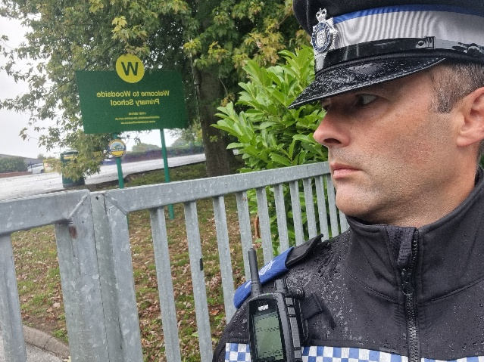

Incidents of note

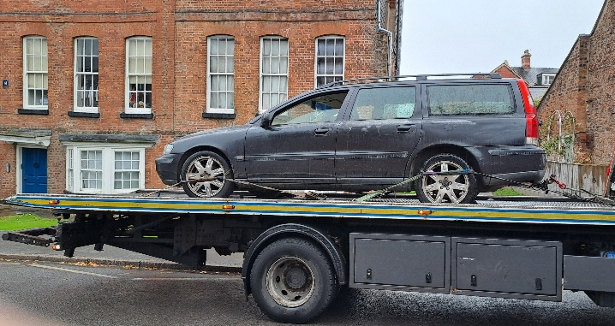

Vehicle seizure on Upper Brook Street Oswestry. Vehicle showing SORN, further checks on the vehicle showed that it did not have MOT or Insurance. This was carried out on the 20/10/2026.

On 7th of October 2026, the TCT successfully tracked down a shoplifter in Oswestry and issued a community resolution to the suspect. He was placed on a victim awareness course and banned from the store.

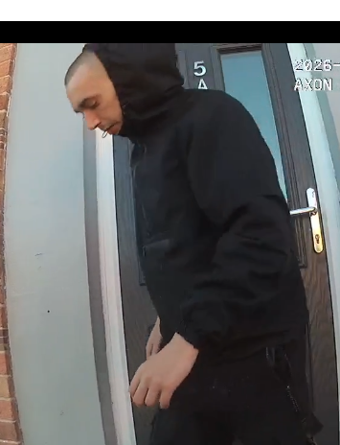

On 8th of October 2026 the TCT assisted with response officers in relation to a domestic incident where a suspect was found inside a property with a vulnerable victim. A domestic violence protection order was in place during that time and force was used to gain entry to the property. The suspect fled to an outhouse and was later located and arrested.

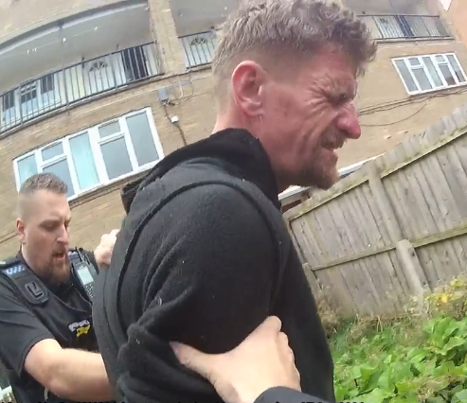

On 13th of October, the TCT collaborated with Rural South SNT and located a male who was identified in a shop theft in Oswestry town centre. He accepted responsibility and agreed to pay the money back and attend a course. Disposed of by way of a community resolution.

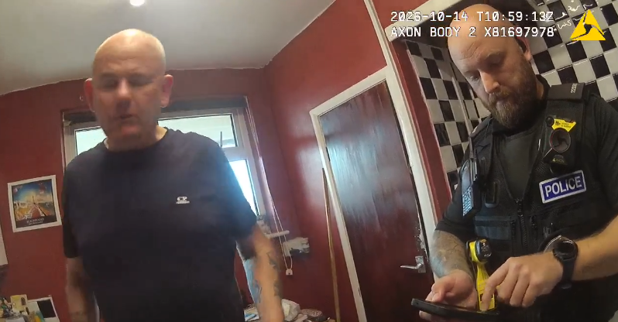

Following significant intelligence and information about drug activity at an address on Unicorn Road, a closure notice has been issued to the occupant. Police encourage members of the public to report any concerns they may have in their community concerning drugs or ASB.

Oswestry Central Officers conducted a traffic operation within the town centre this month to target vehicles being used in an anti-social manner. Numerous vehicles were stopped and the owners/registered keepers were advised and given warning letters about their behaviour. Several vehicles were discovered with expired tax and MOT’s. Please report any vehicles being driven in an anti-social manner or vehicles that are being used without legal documentation.

