
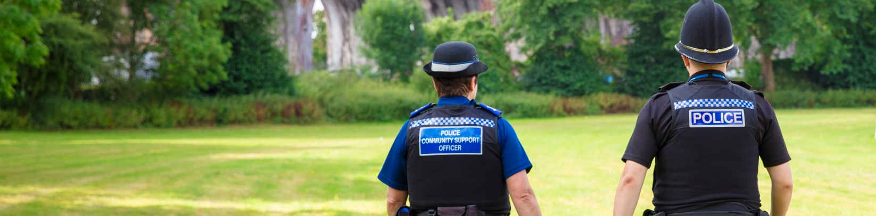
On the beat in Droitwich   | October  2026

Community Engagement

Police Surgery Dates - Droitwich Safer Neighbourhood Team

October – December 2026
We will be holding drop-in surgeries throughout Autumn and invite the local community to attend and chat with us.
Session Type | Location | Date | Time
Drop In | Lidl | 01 October 2026 | 10 am
TBC | Westlands School | 01 October 2026 | 11 am
TBC | Ombersley Memorial Hall | 02 October 2026 | 10:00 10:30 am
Drop In | Holland & Barrett | 05 October 2026 | 1 pm
Bike Marking | Droitwich Leisure Centre | 8 October 2026 | 12 – 2 pm
TBC | Crowle PCM | 8 October 2026 | 7 pm
Drop In | Droitwich Library | 09 October 2026 | 10:30 am
Bike Marking | Droitwich Leisure Centre | 9 October 2026 | 12 – 2 pm
Harvest Lunch | Westlands Church | 11 October 2026 | 1:30 pm
Drop In | Costa Coffee, Tolley Way  Copcut, WR9 7HP | 12 October 2026 | 09:00 – 09:30 am
TBC | Davids Garden Centre | 12 October 2026 | 10:30 11:15 am
Central Residents Meeting | TBC | 13 October 2026 | 6:30 pm
Drop In | Cancer Research | 14 October 2026 | 2 pm
CVS Charity | Old Library | 15 October 2026 | 10 am – 12 pm
Westlands Residents Meeting | WANDS Children’s Centre, Farmers Way | 20 October 2026 | 6 pm
Scam/Security Talk | Tibberton Parish Hall, Tibberton | 24 October 2026 | 12 – 2 pm
Drop In | Iceland | 24 October 2026 | 12 pm
Drop In | Acorns | 28 October 2026 | 2 pm
Scam/Security Talk | Droitwich Mews | 29 October 2026 | 11 am
Drop In | Peacocks | 4 November 2026 | 11 am
Drop In | Emmanuel Church, Blake Avenue, WR9 8PQ | 4 November 2026 | 9:30 – 10 am
Scam/Security Talk | Cookhill Parish Talk, Cookhill Village Hall | 6 November 2026 | 10 – 12 pm
Drop In | Blue Cross | 10 November 2026 | 1 pm
Central Residents Meeting | TBC | 10 November 2026 | 6:30 pm
Scam/Security Talk | Tibberton Parish Hall, Tibberton | 11 November 2026 | 6 – 7:30 pm
Drop In | Waitrose | 14 November 2026 | 4 pm
Drop In | The Watering Can Café, Davids Garden Centre, Ash Lane, WR3 8TB | 16 November 2026 | 1 – 1:30 pm
Scam/Security Talk | TBC, Tibberton | 18 November 2026 | 10 am
Drop In | Home Bargains | 18 November 2026 | 3 pm
Drop In | Aldi | 22 November 2026 | 12 pm
Home Security/Scam Input | TBC, Crowle | 25 November 2026 | 6 – 7 pm
Drop In | Smart Ideas | 28 November 2026 | 1 pm
Drop In | Carers & Community Shop | 30 November 2026 | 2 pm
Drop In | Boots | 02 December 2026 | 4 pm
Central Residents Meeting | TBC | 8 December 2026 | 6:30 pm
Drop In | Costa Coffee, Tolley Way, Copcut, WR9 7HP | 9 December 2026 | 9 – 9:30 am
Drop In | Lidl | 9 December 2026 | 1 pm
Drop In | St Richards Hospice Charity Shop | 17 December 2026 | 3 pm
Drop In | Emmanuel Church, Blake Avenue, WR9 8PQ | 18 December 2026 | 9-9:30 am
Drop In | Morrisons | 24 December 2026 | 11 am

Other News
Sign up to Neighbourhood Matters

Neighbourhood Matters enables residents, businesses and community groups to keep in touch with local policing teams. You can choose exactly what type of alert you wish to receive and how you receive them, whether that is by email, text, or telephone. Sign up now at: www.neighbourhoodmatters.co.uk

Droitwich Police
Current call and crime recording statistics for police and your neighbourhood are available at www.police.uk or using the following link: www.westmercia.police.uk/area/your-area/west-mercia/north-worcestershire/droitwich If you wish to discuss further, please contact a member of your Safer Neighbourhood Team.

How to report an incident
- For crimes in progress call 999
- For non-emergencies report online: www.westmercia.police.uk/report
- If you are unable to report online, you can contact the police via the 101 non-emergency number.

Appeals for information
Criminal Activity
Anyone who believes there may be criminal activity in their community, is urged to report it to us via our website www.westmercia.police.uk/report. Always call 999 in an emergency.

Alternatively, information can be reported 100% anonymously through Independent UK charity Crimestoppers by calling 0800 555111 or visiting https://crimestoppers-uk.org/

It is 100% anonymous, they will never ask your name, and they cannot trace your call or IP address. They will ask questions about the crime but will not ask about you

If you are concerned your call could be traced, dial 141 before 0800 555 111, this will block your phone number. 0800 numbers are free from a landline and do not show up on BT or cable phone bills.

Reporting Fraud
Report Fraud is the UK’s national cyber-crime and fraud reporting service. If you have been the victim of a cyber-crime or fraud, or you suspect one is being attempted, report it to Report Fraud Online reportfraud.police.uk By phone - 0300 123 2040

Meet the Droitwich Safer Neighbourhood Team
The Droitwich Team have recently welcomed a number of new officers who will be operating across the area in support of the existing safer neighbourhood team. Please look out for the team who can be contacted on Droitwich.snt@westmercia.police.uk

New Staff Poster/Team Members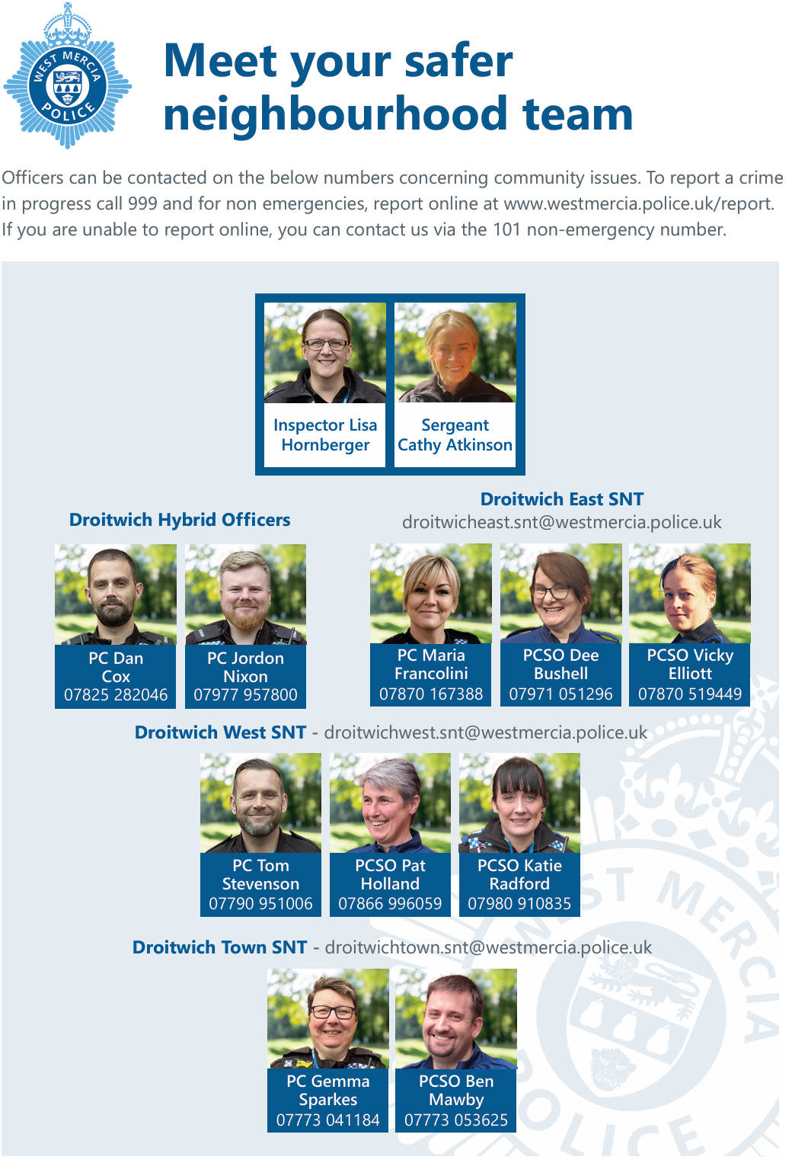rsr Photos

Good News Stories
There have been two individuals reported for using e-scooters, and having no insurance or driving license, and the SNT team continue to target illegal bikes and scooters, along with investigations in connection with shoplifting.
In further good news stories two males have been arrested for commercial burglaries, resulting in one bail with curfew and remand to prison.

Securing Property
With the dark night’s drawing in we are sharing simple ways to protect your home. Burglars prefer to operate in the dark, they will often pick a property that seems vacant, but you can help yourself from being a victim of crime. Home security is the best way to reduce your chances of being burgled.
Tips to consider keeping your home safe during dark nights:
- Securely lock all doors and windows before leaving the house
- Never leave keys by the front door, including your letterbox; burglars know where to look
- Leave interior lights on or put them on an automatic timer, and consider leaving a radio on
- Security lights given the impression someone is in and removes the element of darkness, install an external security light, and put exterior lights on a sensor
- Consider installing CCTV on your property
- Keep your eye out for neighbours
If you have any concerns speak to an expert or more crime prevention advice can be found here: www.westmercia.police.uk/cp/crime-prevention/
Protect your car and valuables
Most vehicle crime is opportunistic and happens as a result of a vehicle being left vulnerable or unsecured. You can help prevent thieves from striking by following these tips.
- Park somewhere safe; a garage or a well-lit street
- Reduce the risk of theft, use alarms, immobilisers and locking devices
- Take valuables with you and remove obvious targets such as laptops, SatNavs, and Dashcams where possible
- Every time you leave your car, lock the doors and close the windows
- Car keys should never be left in the ignition if you are away from your car
- Thieves enter homes to take keys, remove them from accessible areas and place in a metal/foil lined box or another signal blocking container to prevent the key signal reaching the vehicle
- Consider purchasing an additional security device such as a steering wheel lock, wheel clamp or parking post.

Upcoming Droitwich Community Events
A big thank you to all those involved in making the summer events such a success, and to everyone who came along and supported them throughout the season
Further information can be found on featured and upcoming events, through the Droitwich Spa Town Council websites: www.visitdroitwichspa.com and www.droitwichspa.gov.uk

Session Type | Location | Date | Time
Wychavon Civic Service | St Peters Church | 04 October 2026
Bike Night | High Street | 08 October 2026
Walkabout with Tim Lewis | Hampton Lovett Ind Estate | 14 October 2026
Droitwich Business Awards | Sixways | 15 October 2026
Breakfast Meet | Droitwich Mews | 30 October 2026
Remembrance Service | Victoria Square | 08 November 2026
Remembrance Commemoration | Dodderhill School | 10 November 2026
Armistice Day | St Richards House/Victoria Square | 11 November 2026
Bad Emms Twinning Association AGM | Westlands Church | 16 November 2026
Santas Grotto | St Richards House | 21 November 2026 | 12 noon onwards
Market Stalls & Fun Fair | Victoria Square | 21 November 2026?
Christmas Lights Switch on | Victoria Square | 21 November 2026 | 6 pm

Droitwich Arts Network

Droitwich Arts Network (DAN) is a “not for profit” Community Interest Company that advocates and champions all forms of art in the Droitwich area, including visual arts, performing arts, photography, media, written, music and crafts. The network provides the opportunity for artists to display or perform their work, and for the public to participate in various projects and events that will take place over the next few months.
For more information and details of events visit their website on https://droitwichartsnetwork.org

Droitwich Community Garden

Mr Beestan’s community garden was established using lottery funding in 2010, by the then community officer and volunteers, on the corner of Charles Henry Road and Winslow Avenue.
Volunteers meet on Mondays at 11-1 but anyone is welcome to go along for a potter.
The garden is used as a community space for people to enjoy, and volunteers grow flowers, vegetables and maintain it, there is also a raised bed maintained with a local school as a project for their eco council.
In the past produce has been donated to the foodbank with the garden and team winning RHS and Wychavon Community Awards.
The new team of volunteers are now on the lookout for more hands!

