Dear All,

Please find attached information that outlines the traffic management arrangements for a temporary road closure along Cordingley Way, Donnington.

Severn Trent Water are planning to undertake new connection works. The work is set to commence on Monday 15th June 2026 and will last for a duration of 5 days with an end date of Friday 19th June 2026.

The diversion route for vehicular traffic travelling in all directions will be signed on site

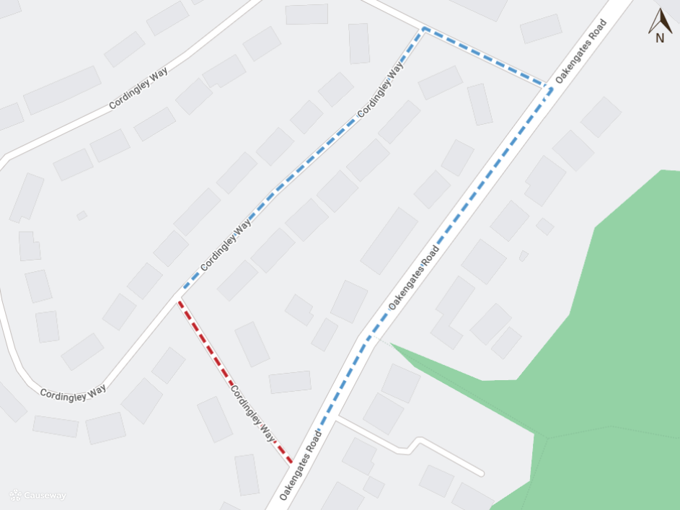
Imagery © 2026 MapTiler | Imagery © 2026 Hexagon | © MapTiler © OpenStreetMap contributors

Should you have any questions or comments on the above, please do not hesitate to contact us.

Kind Regards,
Streetworks Team
Strategic Transport & Highway Network Management
Neighbourhood & Enforcement Services
Telford & Wrekin Council
01952 384000
www.telford.gov.uk

