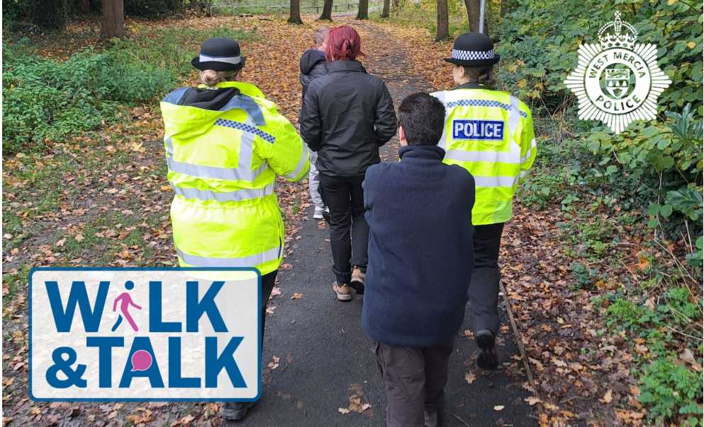

Walk and

Talk


Hub on the Hill, Sutton Hill, TF7 4HG
Wednesday 27th May 2026
2pm – 3pm

Brookside Community Centre, TF3 1LP

Thursday 28th May 2026
10:30-11:30am

- Walk and Talk is an initiative which aims to tackle violence against women and girls (VAWG)
- Opportunity to discuss concerns around personal safety, anti-social behaviour, sexual and domestic abuse offences in your community with a female officer
- Open for all women and girls
- Bring a friend and/or family members
- Forms part of Telford Walk Week. Please follow the link below for other events that are on offer around the Borough, suited for people of all abilities and interests.
- Telford Walk Week 2026 - Visit Telford

